**CSE220: Data Structures (Lab)**

**Fall 2024**

**Lab Quiz - 05**

**Total Marks: 15, Duration: 40 Minutes**

| Name: | ID: | Section: |
| --- | --- | --- |

### **Question 1 [7]**

Given the root of a **binary tree**, write a function to calculate the **sum** of **all** such nodes that have **exactly one child** and **belong to an odd level**. Consider the root to be at level 0.

For example, in the following binary tree, nodes that belong to an odd level are 21, 35, and 9. Only the node 35 has one child, so the sum will be 35.

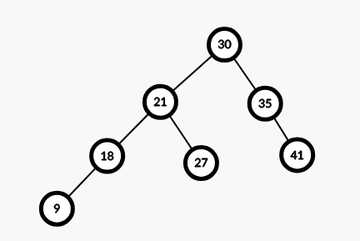

**Question 2 [8]**

Given the root of a **Binary Search Tree (BST)** and a number **x**, write a function to find the **floor** of **x** in the given BST, where **floor** means **the largest value node of the BST which is smaller than or equal to x.** If x is smaller than the smallest node of BST then return -1. Suppose all node values are positive. Following sample inputs and outputs are for the tree given in question 1.

| **Sample Input** | **Sample Output** | **Explanation** |
| --- | --- | --- |
| root, 20 | 18 | Nodes with value smaller than 20 are 18 and 9; of them 18 is closest to 20. |
| root, 21 | 21 | Nodes with value smaller than or equal to 21 are 9, 18 and 21; of them 21 itself is closest to 21. |
| root, 7 | -1 | 7 is smaller than the smallest node of the BST (9). |